9-1 Cellular Respiration

__________ serves as a source of raw materials for the cells in the body and as a source of energy.
Both plant and animal cells carry out the final stages of _________________________________.
Chemical Energy and Food
One gram of the sugar glucose (C₆H₁₂O₆), when burned in the presence of oxygen, releases 3811 calories of heat energy.
A ________________is the amount of energy needed to raise the temperature of 1 gram of water 1 degree Celsius.
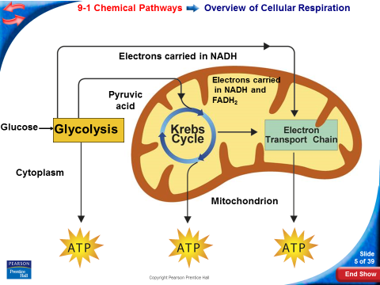

Cellular respiration is the process that releases energy by _____________________________________ and other food molecules in the presence of _________________.
The equation for cellular respiration is:
__________________________________________________________________
___________________________________________________________________
_______________________________________________. The Krebs cycle and electron transport take place in the mitochondria.

ATP Production
At the beginning of glycolysis, the cell uses up 2 molecules of ATP to start the reaction.
When glycolysis is complete_____________________ molecules have been produced.
This gives the cell a ____________________________ molecules.
NADH Production
One reaction of glycolysis removes 4 high-energy electrons, passing them to an electron carrier called NAD⁺.
Each NAD⁺ accepts a pair of high-energy electrons and becomes an NADH molecule.
The NADH molecule holds the electrons until they can be transferred to other molecules.
The Advantages of Glycolysis
The process of glycolysis is so fast that cells can produce thousands of ATP molecules in a few milliseconds.
_________________________________________________________________
Fermentation
When oxygen _______________________, glycolysis is followed by a different pathway. The combined process of this pathway and glycolysis is called fermentation.
______________________________ releases energy from food molecules by producing ATP in the absence of oxygen.
During fermentation, cells convert NADH to NAD⁺ by passing high-energy electrons back to pyruvic acid.
This action converts NADH back into NAD⁺, and allows glycolysis to continue producing a steady supply of ATP.
Fermentation does not require oxygen—it is an ________________________process.
Alcoholic Fermentation
Yeasts and a few other microorganisms use ____________________________________, forming ethyl alcohol and carbon dioxide as wastes.
The equation for alcoholic fermentation after glycolysis is:
pyruvic acid + NADH → alcohol + CO₂ + NAD⁺
Lactic Acid Fermentation
In many cells, pyruvic acid that accumulates as a result of glycolysis can be converted to lactic acid.
This type of fermentation is called _______________________________. It regenerates NAD⁺ so that glycolysis can continue.
The equation for lactic acid fermentation after glycolysis is:
pyruvic acid + NADH → lactic acid + NAD⁺

9-2 Krebs Cycle and Electron Transport Train
Oxygen is required for the final steps of cellular respiration.
Because the pathways of cellular respiration require oxygen, they are ________________
During the Krebs cycle, ______________________________________________________________ in a series of energy-extracting reactions.
- The Krebs cycle begins when pyruvic acid produced by glycolysis enters the mitochondrion.
- One carbon molecule is removed, forming CO₂, and electrons are removed, changing NAD⁺ to NADH.
- Coenzyme A joins the 2-carbon molecule, forming acetyl-CoA.
- Acetyl-CoA then adds the 2-carbon acetyl group to a 4-carbon compound, forming citric acid.
- Citric acid is broken down into a 5-carbon compound, then into a 4-carbon compound.
- Two more molecules of CO₂ are released and electrons join NAD⁺ and FAD, forming NADH and FADH₂
- In addition, one molecule of ATP is generated.
The energy tally from 1 molecule of pyruvic acid is
      - 4 NADH
      - 1 FADH₂
      - 1 ATP
Electron Transport
- The electron transport chain uses the high-energy electrons from the Krebs cycle to convert ADP into ATP.
- High-energy electrons from NADH and FADH₂ are passed along the electron transport chain from one carrier protein to the next.
- At the end of the chain, an enzyme combines these electrons with hydrogen ions and oxygen to form water.
- As the final electron acceptor of the electron transport chain, oxygen gets rid of the low-energy electrons and hydrogen ions.
- When 2 high-energy electrons move down the electron transport chain, their energy is used to move hydrogen ions (H⁺) across the membrane.
- During electron transport, H⁺ ions build up in the intermembrane space, so it is positively charged.
- The other side of the membrane, from which those H⁺ ions are taken, is now negatively charged.
- The inner membranes of the mitochondria contain protein spheres called ATP synthases.
- As H⁺ ions escape through channels into these proteins, the ATP synthase spins.
- As it rotates, the enzyme grabs a low-energy ADP, attaching a phosphate, forming high-energy ATP.

The Totals
Glycolysis produces just 2 ATP molecules per molecule of glucose.
The complete breakdown of glucose through cellular respiration, including glycolysis, results in the production of 36 molecules of ATP.
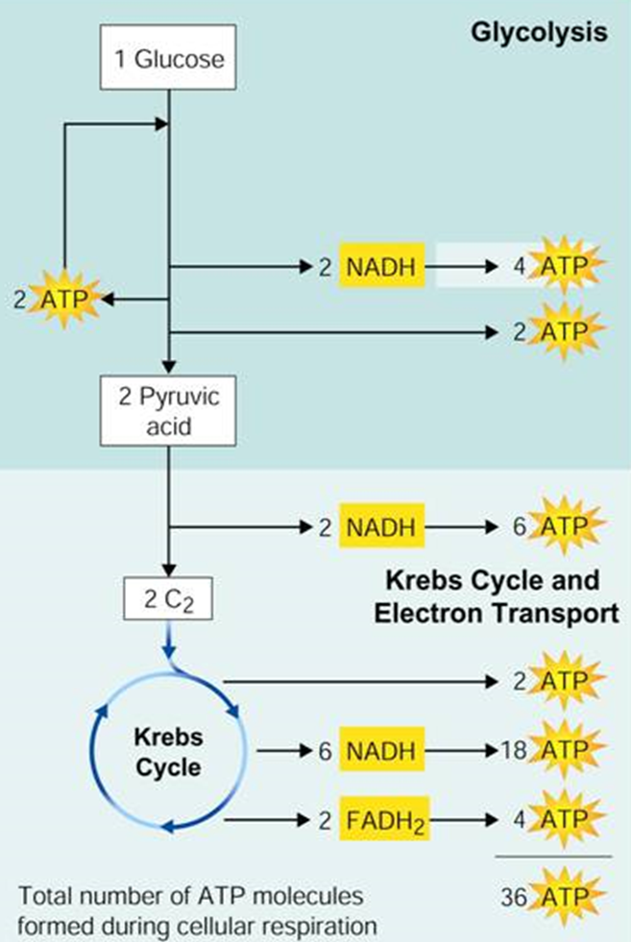

Comparing Photosynthesis and Cellular Respiration
The energy flows in photosynthesis and cellular respiration take place in opposite directions.
