Chapter 4: INTRODUCTION TO THE CELL

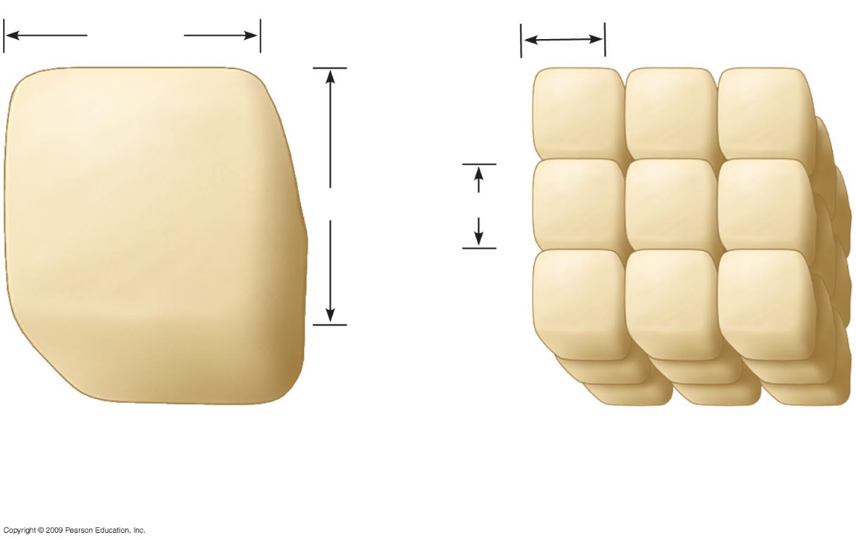
4.3 Prokaryotic cells are structurally simpler than eukaryotic cells
- Bacteria and archaea are ______________________cells
- All other forms of life are ___________________________ cells
  - ______________ prokaryotic and eukaryotic cells have a ___________________ and one or more chromosomes and ribosomes
  - Eukaryotic cells have a membrane-bound nucleus and a number of other _______________________, whereas prokaryotes have a nucleoid and no true organelles

4.4 Eukaryotic cells are partitioned into functional compartments
- There are four life processes in eukaryotic cells that depend upon structures and organelles
  - ______________________________
  - ______________________________
  - ______________________________
  - ______________________________, movement, and communication

4.4 Eukaryotic cells are partitioned into functional compartments
- Manufacturing involves the nucleus, ribosomes, endoplasmic reticulum, and Golgi apparatus
  - Manufacture of a protein, perhaps an enzyme, involves all of these

4.4 Eukaryotic cells are partitioned into functional compartments
- Breakdown of molecules involves ________________________________________
  - Breakdown of an internalized bacterium by a phagocytic cell would involve all of these

4.4 Eukaryotic cells are partitioned into functional compartments
- Energy processing involves _______________________ in animal cells and ________________________ in plant cells
  - Generation of energy-containing molecules, such as adenosine triphosphate, occurs in mitochondria and chloroplasts

4.4 Eukaryotic cells are partitioned into functional compartments
- Structural support, movement, and communication involve the ___________________________________________________________________
  - An example of the importance of these is the response and movement of phagocytic cells to an infected area

4.4 Eukaryotic cells are partitioned into functional compartments
- ___________________________________ within a eukaryotic cell partition the cell into compartments, areas where cellular metabolism occurs
  - Each compartment is fluid-filled and maintains conditions that favor particular metabolic processes and activities

4.4 Eukaryotic cells are partitioned into functional compartments
- Although there are many similarities between animal and plant cells, differences exist
  - ________________________________________________________________
  - ________________________________________________________________

4.5 The structure of membranes correlates with their functions
- The _________________________________ controls the movement of molecules into and out of the cell, a trait called selective permeability
  - The structure of the membrane with its component molecules is responsible for this characteristic
  - Membranes are made of lipids, proteins, and some carbohydrate, but the most abundant lipids are phospholipids

4.5 The structure of membranes correlates with their functions
- Phospholipids form a two-layer sheet called a _____________________________
  - Hydrophilic heads face outward, and hydrophobic tails point inward
  - Thus, hydrophilic heads are exposed to water, while hydrophobic tails are shielded from water
- Proteins are attached to the surface, and some are embedded into the phospholipid bilayer

CELL STRUCTURES INVOLVED IN MANUFACTURING AND BREAKDOWN

4.6 The nucleus is the cell’s genetic control center
- The __________________ controls the cell’s activities and is responsible for inheritance
  - Inside is a complex of proteins and DNA called __________________, which makes up the cell’s chromosomes
  - DNA is copied within the nucleus prior to cell division

4.6 The nucleus is the cell’s genetic control center
- The _______________________________ is a double membrane with pores that allow material to flow in and out of the nucleus
  - It is attached to a network of cellular membranes called the endoplasmic reticulum

4.7 Ribosomes make proteins for use in the cell and export
- ___________________________ are involved in the cell’s protein synthesis
  - Ribosomes are synthesized in the nucleolus, which is found in the nucleus
  - Cells that must synthesize large amounts of protein have a large number of ribosomes

4.7 Ribosomes make proteins for use in the cell and export
- Some ribosomes are __________________________________________
  - Free ribosomes are suspended in the cytoplasm
  - Bound ribosomes are attached to the endoplasmic reticulum (ER) associated with the nuclear envelope

4.8 Overview: Many cell organelles are connected through the endomembrane system
- The membranes within a eukaryotic cell are physically connected and compose the ________________________________________
  - The endomembrane system includes the nuclear envelope, endoplasmic reticulum (ER), Golgi apparatus, lysosomes, vacuoles, and the plasma membrane

4.8 Overview: Many cell organelles are connected through the endomembrane system
- Some components of the endomembrane system are able to communicate with others with formation and transfer of small membrane segments called _______________
  - One important result of communication is the synthesis, storage, and export of molecules

4.9 The endoplasmic reticulum is a biosynthetic factory
- There are two kinds of endoplasmic reticulum—smooth and rough
- __________________ lacks attached ribosomes
- _________________lines the outer surface of membranes
  - They differ in structure and function
  - However, they are connected

4.9 The endoplasmic reticulum is a biosynthetic factory
- Smooth ER is involved in a variety of diverse _____________________________
  - For example, enzymes produced by the smooth ER are involved in the synthesis of lipids, oils, phospholipids, and steroids

4.9 The endoplasmic reticulum is a biosynthetic factory
- Rough ER makes additional membrane for itself and ___________________ destined for secretion
  - Once proteins are synthesized, they are transported in vesicles to other parts of the endomembrane system

4.10 The Golgi apparatus finishes, sorts, and ships cell products
- The ___________________________________ functions in conjunction with the ER by modifying products of the ER
  - Products travel in transport vesicles from the ER to the Golgi apparatus
  - One side of the Golgi apparatus functions as a receiving dock for the product and the other as a shipping dock
    - Products are modified as they go from one side of the Golgi apparatus to the other and travel in vesicles to other sites

4.12 Vacuoles function in the general maintenance of the cell
- ___________________________ are membranous sacs that are found in a variety of cells and possess an assortment of functions
  - Examples are the central vacuole in plants with hydrolytic functions, pigment vacuoles in plants to provide color to flowers, and contractile vacuoles in some protists to expel water from the cell

4.14 Mitochondria harvest chemical energy from food
- Cellular respiration is accomplished in the ______________________________ of eukaryotic cells
  - Cellular respiration involves conversion of chemical energy in foods to chemical energy in ATP (adenosine triphosphate)
  - Mitochondria have two internal compartments
    - The _______________________________, which encloses the ______________________________ where materials necessary for ATP generation are found

4.15 Chloroplasts convert solar energy to chemical energy
- ____________________________ are the photosynthesizing organelles of plants
  - _________________________________ is the conversion of light energy to chemical energy of sugar molecules
- Chloroplasts are partitioned into compartments
  - The important parts of chloroplasts are the stroma, thylakoids, and grana

4.16 EVOLUTION CONNECTION: Mitochondria and chloroplasts evolved by endosymbiosis
- When compared, you find that mitochondria and chloroplasts have (1) DNA and (2) ribosomes
  - The structure of both DNA and ribosomes is very similar to that found in prokaryotic cells, and mitochondria and chloroplasts replicate much like prokaryotes
- The hypothesis of _____________________________ proposes that mitochondria and chloroplasts were formerly small prokaryotes that began living within larger cells
  - Symbiosis benefited both cell types

INTERNAL AND EXTERNAL SUPPORT: THE CYTOSKELETON AND CELL SURFACES
4.17 The cell’s internal skeleton helps organize its structure and activities
- Cells contain a network of protein fibers, called the ________________________, that functions in cell structural support and motility
  - Scientists believe that motility and cellular regulation result when the cytoskeleton interacts with proteins called motor proteins

- 4.17 The cell’s internal skeleton helps organize its structure and activities
- The cytoskeleton is composed of three kinds of fibers
  - __________________________________(actin filaments) support the cell’s shape and are involved in motility
  - ____________________________________ reinforce cell shape and anchor organelles
  - _____________________________________ (made of tubulin) shape the cell and act as tracks for motor protein

4.18 Cilia and flagella move when microtubules bend
- While some protists have _________________________________ that are important in locomotion, some cells of multicellular organisms have them for different reasons
  - Cells that sweep mucus out of our lungs have cilia
  - Animal sperm are flagellated

4.20 The extracellular matrix of animal cells functions in support, movement, and regulation
- Cells synthesize and secrete the __________________________________ that is essential to cell function
  - The ECM is composed of strong fibers of collagen, which holds cells together and protects the plasma membrane

4.22 Cell walls enclose and support plant cells
- Plant, but not animal cells, have a rigid ____________________________
  - It protects and provides skeletal support that helps keep the plant upright against gravity
  - Plant cell walls are composed primarily of cellulose
- Plant cells have cell junctions called _______________________________ that serve in communication between cells

FUNCTIONAL CATEGORIES OF CELL STRUCTURES

