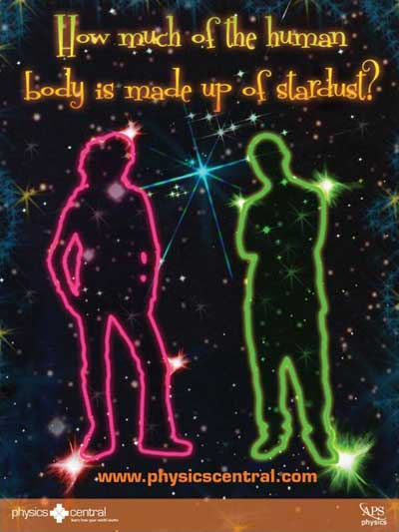
How much of the human body is made up of stardust?
Did you ever wonder where you came from? That is the stuff that’s inside your body like your bones, organs, muscles…etc. All of these things are made of various molecules and atoms. But where did these little ingredients come from? And how were they made? The answer to these questions will take us back to a time long ago when the universe was much different than it is now. However, the physics was the same.
The early universe expanded after the big bang for only 3 seconds before it cooled to a state where subatomic particles assembled into atoms. Hydrogen atoms formed first since they are the simplest type of atom. Hydrogen atoms contain only one proton in its nucleus, which makes it number one on the periodic table of elements. After the universe aged a little (roughly 300 million years) the hydrogen atoms started to clump together under the force of gravity. As these clumps grew in size, the pressure at the center grew larger. When the temperature reached 15 million degrees F, the pressure caused the hydrogen to fuse their nuclei together. This process is known as nuclear fusion. The positively charged nuclei naturally repel each other. However under high temperatures and pressure, the nuclei are moving fast enough to smash together and fuse. When the two proton nuclei of the hydrogen atoms fuse, they form a nucleus consisting of two protons. Some electrons also combine with protons to form neutrons and neutrinos. These neutrons also bind to the nucleus helping it to remain more stable under the nuclear forces. An atom with two protons in its nucleus is Helium. That’s why helium is number two on the periodic table of elements. The fusion process also releases a lot of energy in which some of the hydrogen mass converts into light energy. This conversion of mass in to energy uses Einstein’s famous equation: E=mc².
At this point, our universe has a bunch of large clumps of hydrogen fusing together to create helium while releasing large amounts of light. This is what we commonly call a star! In fact our sun is doing this right now as we speak (or read). As a star ages, it then fuses the helium with hydrogen to form lithium which has three protons in its nucleus. Take a look at the periodic table to see which number it is. This fusion process continues to create larger and larger nuclei. The forth, the fifth and all the way up to 26th.
This is the general idea but it’s not exactly this easy. We have to remember that this is in fact nuclear physics that we’re dealing with here. It looks like a pretty simple picture as we just described but up close it is actually an intricate jigsaw puzzle.
The fusion process doesn’t actually create the elements in order through the periodic table. In fact, the process jumps around. And some fused nuclei decay down to lower elements that were skipped over. Fusion also creates neutrons, which combine with atoms to create isotopes, which act like atomic cousins. Overall, we can say that a star produces all of the elements up to iron in the periodic table through the fusion process. The details of this process are fascinating, yet they deter us from answering the question at hand.
The element with 26 protons in its nucleus is iron. It turns out that this is the last element that is created. To create higher elements, fusion requires more energy than it produces. We mentioned earlier that a star glows because the fusing atoms release energy (E=mc²). However, the amount of energy released becomes smaller and smaller as the atoms grow larger. Eventually at iron, there is no energy released at all. And for elements beyond iron, more energy is need for fusion than gravitational pressure can provide.
After a star has created enough iron, fusion ceases and the hot burning core begins to cool. Up until this point the hot core of the star erupting outwards and preventing gravity from collapsing the star. Now that the star has cooled, the core no longer expands and gravity quickly collapses the star. The star implodes with enough energy to immediately fuse some of the atoms into higher elements like Nickel, Krypton, Gold, Uranium,… etc. This quick and violent implosion releases an enormous amount of energy that explodes the star. This is what we call a supernova! Astrophysicists are still not exactly certain about the details of how a supernova explodes. Hopefully you can figure it out someday!
The exploded remains from a supernova travel through out the universe only to someday clump together with other stardust and give birth to a new star. This is the life of our universe.
Now that we have established that every element in the periodic table aside from hydrogen is essentially stardust, we have to determine how much of our body is made up of this stardust. If we know how many hydrogen atoms are in our body, then we can say that the rest is stardust. Our body is composed of roughly 7x10²⁷ atoms. That is a lot of atoms! Try writing that number out on a piece of paper: 7 with 27 zeros behind it. We say roughly because if you pluck a hair or pick your nose there might be slightly less. Now it turns out that of those billion billion billion atoms, 4.2x10²⁷ of them are hydrogen. Remember that hydrogen is big bang dust and not stardust. This leaves 2.8x10²⁷ atoms of stardust. Thus the amount of stardust atoms in our body is 40%.
Since stardust atoms are the heavier elements, the percentage of star mass in our body is much more impressive. Most of the hydrogen in our body floats around in the form of water. The human body is about 60% water and hydrogen only accounts for 11% of that water mass. Even though water consists of two hydrogen atoms for every oxygen, hydrogen has much less mass. We can conclude that 93% of the mass in our body is stardust. Just think, long ago someone may have wished upon a star that you are made of.

